Department of Veterans Affairs (VA)   
  
Benefits Claims Decision Support System (BCDSS)  
  
User Manual

**VA118-1015-0036  
CLIN: 0004AA**



**December 2016**

**Version 0.9**

Revision History

|  |  |  |  |  |
| --- | --- | --- | --- | --- |
| Date | Version | Description | Author | Reviewer(s) |
| 2016-11/10 | 0.9 | [Added Advanced filter pop-up](#_Advance_Filter_Claim(s)), [updated Dashboard screen](#_Home_Screen_(Dashboard)), updated Result screen, Updated Panel details | CJ Puttaswamy |  |
| 2016-11/10 | 0.8 | Added Reports, [updated Results tab](#_Review_the_Result(s)) | CJ Puttaswamy | Evan Weber |
| 2016-10/20 | 0.7 | No updates | CJ Puttaswamy | Evan Weber |
| 2016-9/20 | 0.6 | Added Administrator functions – Create User, Edit User, Reset Password | CJ Puttaswamy | Evan Weber |
| 2016-9/15 | 0.5 | Changes to match template and editorial corrections |  | Evan Weber |
| 2016-08/23 | 0.4 | Updated the screenshots of Login screen, and [Home(Dashboard)](#_Home_(Dashboard)) | CJ Puttaswamy |  |
| 2016-07/27 | 0.3 | [Added User Interface features in detail. Updated screenshots, provided details of the Rater’s Happy path](#_Home_(Dashboard)) | CJ Puttaswamy |  |
| 2016-06/29 | 0.2 | Updated BCDS specifics till date details | CJ Puttaswamy | Rebecca DeJesus |
| 2016-04/20 | 0.1 | Created BCDSS template. | E Rothwell |  |

Table of Contents

Purpose of this Document 5

Workstation Settings 5

Related Tasks 5

Welcome to BCDSS 5

Getting Started 5

Understanding Permission Levels 5

Requesting a BCDSS User Account 6

Understanding Session Termination 6

Log into the Application 6

User Interface Features 7

Top and Bottom Flyout Panels 7

Icon Bar on Tables 8

Home Screen (Dashboard) 8

Selecting Claim(s) to Process the Model 8

Selecting Models for the Selected Claim 9

Administrator–Dashboard 11

Administrator–Create User 11

Administrator – Edit User 12

Administrator – Reset Password 13

Reports 13

Approval Signatures 15

# Purpose of this Document

This document provides guidance in the use of the BCDSS application for all user roles. The User Manual lists the steps required by the Rater and the Modeling Agent to manage the application and perform claim related tasks. The use of the BCDSS system as the Administrator has been described in the BCDSS System Administrator Guide.

### Workstation Settings

BCDSS is designed to be viewed with Internet Explorer (IE) 11.0 at a minimum screen resolution of 1024x768 and the default Medium text size. (The medium text size can be set from the IE menu bar with the option ***View > Text > Medium****)*. In addition, BCDSS is best viewed with a 4:3 standard-sized monitor (A widescreen monitor is also acceptable.)

### Related Tasks

See the following related topics to started using BCDSS:

* Logging into the Application
* Requesting a BCDSS User Account
* Understanding Permission Levels
* Understanding Session Termination

# Welcome to BCDSS

This user guide is a print version of the BCDSS Online Help, which can be accessed anytime from the BCDSS application by clicking the “Help” link on the top right corner of the home page.

This section contains the following topics designed to get you up and running quickly with BCDSS.

* Getting Started
* Understanding Permission Levels
* Requesting a BCDSS User Account
* Understanding Session Termination
* Log into the Application

## Getting Started

Before you can use the Benefits Claims Decision Support System (BCDSS), you must request and receive a BCDSS user name and password. See Requesting a BCDSS User Account for instructions.

Getting Additional Help

For additional help using the BCDSS application, contact the BCDSS Team at:

**Phone**: TBD

**Email**: TBD

## Understanding Permission Levels

The BCDSS permission levels are described in the following **BCDSS Permissions** matrix. The C*,* R, U, and D acronyms used in the figure denote Create, Read, Update, and Delete.

|  |  |  |  |  |
| --- | --- | --- | --- | --- |
| **Roles and Permissions** | | | | |
| **Permissions** | **Action** | **Rater** | **Modeling Agent** | **Administrator** |
| Dashboard | R | **Y** | **Y** |  |
| Run Model | R | **Y** | **Y** |  |
| Results View | R | **Y** | **Y** |  |
| Reports View | R | **Y** | **Y** |  |
| Manage Model | U |  | **Y** |  |
| Edit Model | U |  | **Y** |  |
| Manage Users | C, R, U, D |  |  | **Y** |
| User Permissions | U |  |  | **Y** |

## Requesting a BCDSS User Account

Rating specialists and Modelling Agents could request access to BCDSS application to the BCDS Administrator.

## Understanding Session Termination

The BCDSS adheres to the Veterans Affairs (VA) security policy of terminating a user session after a period of 60 minutes of inactivity. You will receive a two-minute warning before your session terminates.

If your session does time out, you will be redirected to the Login screen to log into BCDSS again. You should note that you will be directed to the BCDSS Homepage screen the next time you log into BCDSS, not to the location where you last were when your session ended.

## Log into the Application

To log into BCDSS, perform the following steps from your browser’s address bar:

1. Navigate to https://www.bcds.com (url need to be updated when ready); the BCDSS login screen shown below displays:

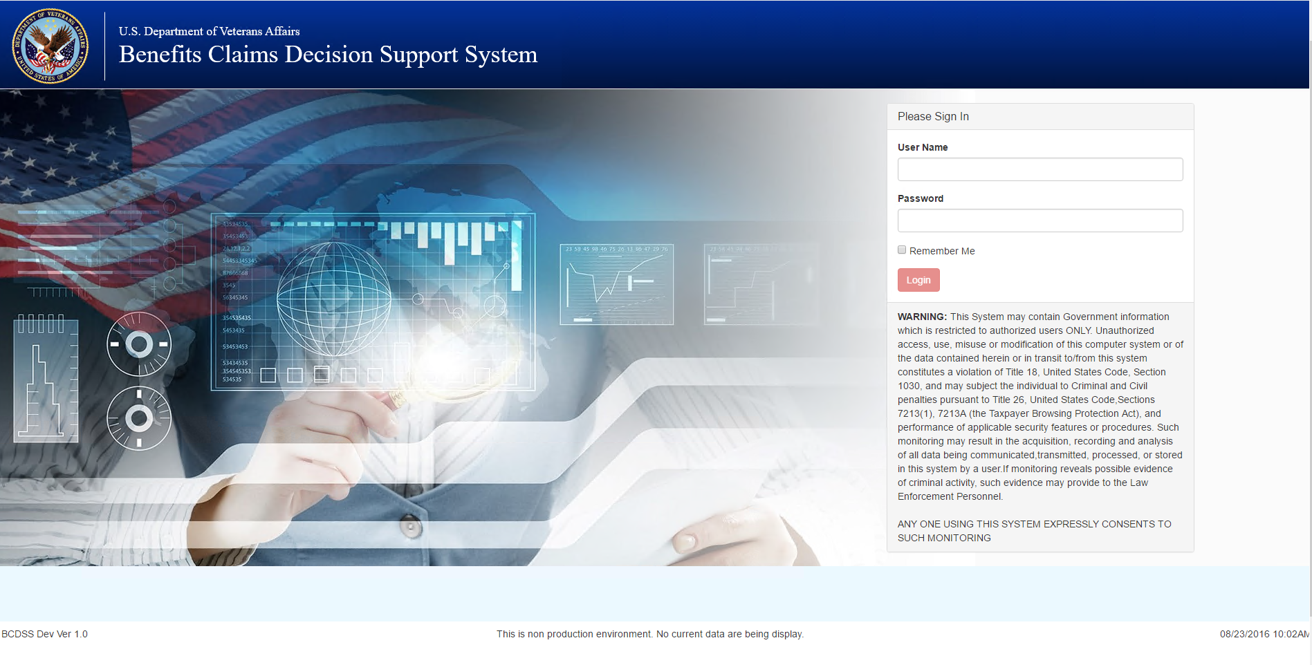

1. Enter your user name in the **User Name** field.
2. Enter your password in the **Password** field.
3. Click **Login** button. The BCDSS home page displays. For more information, see The Home Page.

# User Interface Features

The BCDSS application uses tabbed pages to group the different functional elements of the application. The page is the top-level organizing element in the application, and within this page are tabs that organize the features of the application by functional areas.

The pages of the application are:

1. Dashboard (Home), where you retrieve claims
2. Result, where you view the results from the Models
3. Reports, where you view the reports

## Top Panel

The top panel is open by default when you login to the application

* Click the **Help** icon to view the user manual.
* **Sign Out** under the person iconto sign out of BCDSS and return to the login screen.



## Bottom Pannel

* The bottom flyout panel displays the build number on the left side and the last build date and time on the right side
* The bottom lfet of the grid displays the claim available (numbers), and on the bottom right of the grid option to navigate to the different pages of the grid to view available claims



## Left Panel

* The left side of the dashboard is the navigation panel to navigate between Dashboard, Results, and Report pages



## Home Screen (Dashboard)

The following section describes elements of the BCDSS user interface and a few special pop-up tools that appear based on the user-accessed functionality. The screen captures are examples for illustrative purposes and may differ slightly from the screens that you are viewing in the application.

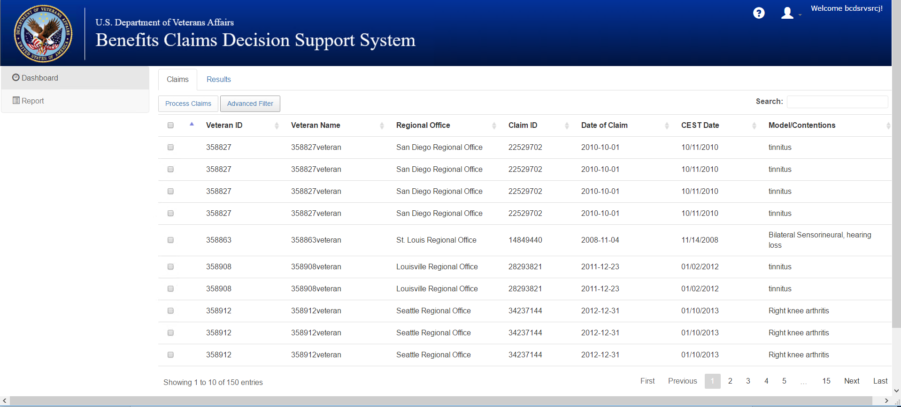

Figure : Home Screen (Dashboard)

## Selecting Claim(s) to Process the Model

The Claim Selection feature is used to select one or more claims from the retrieved claims. To perform this function, perform these steps from the Home screen:

1. Select the desired claim(s) from the retrieved historical claims list by checking the checkboxes on the left end of each claim. .
2. Select **Process Claims** on the top left to process the claims.
3. Selecting **Reset** would reset the selections made on the Table.

## Search Claim(s) to Process

1. Search the claims by entering the value on the **Search** box located on the top right of the grid.

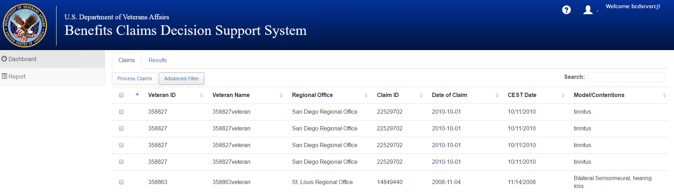

Figure Search Claim(s)

## Advance Filter Claim(s) to Process

1. By selecting the **Advanced Filter**, the claims could be further narrowed down by date range and Regional Office.

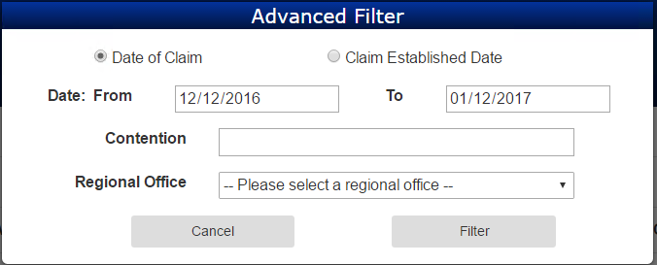

Figure Advanced Filter

## Review the Result(s) of the Model Output

1. Results of the processed claim(s) are displayed in the table.
2. The Model output/results are shown in the **Model Results** column.
3. The actual manually Rated Evaluation is displayed in the **Rated Evaluation** column.
4. Comparisons of the **Model Results** and **Rated Evaluation** are shown in the **Do the results Match?** column.

The Rater/Modeling Agent will be able to Agree/Disagree the Model Evaluation in the **Agree(Y/N)** column. Scroll to the lower right of the screen and click **Save** to save themodel results and its details.

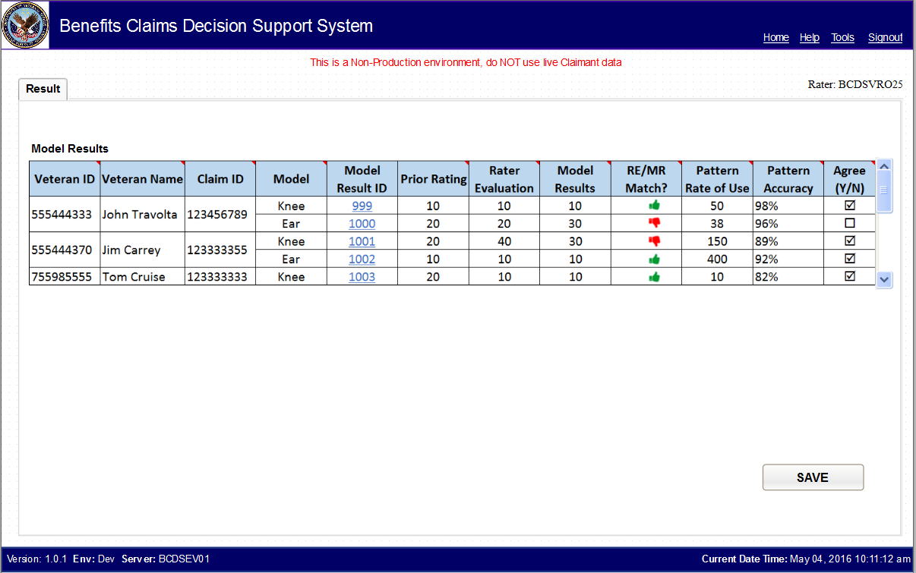

Figure : Results Page—Displaying Results

# Administrator–Dashboard

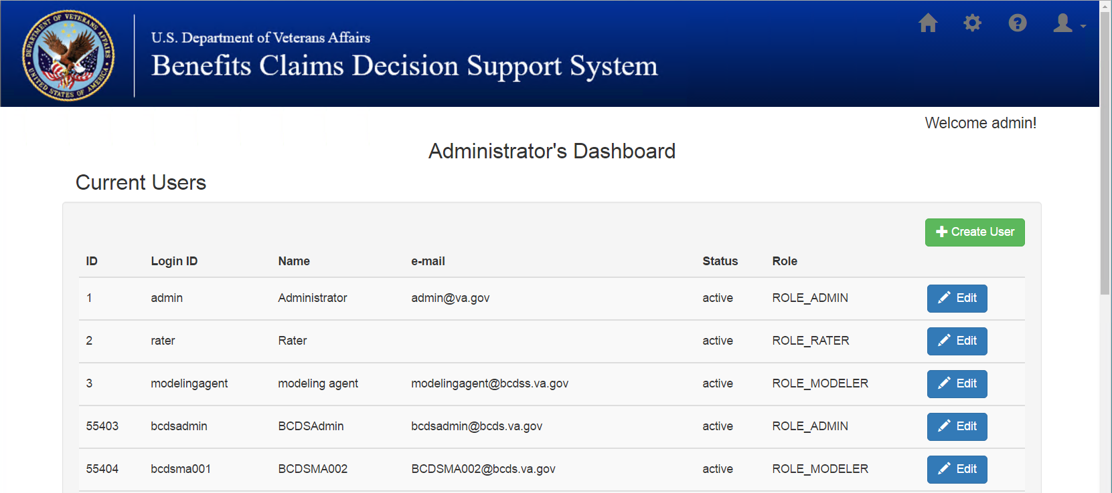

Figure : Administrator's Dashboard

Only an Administrator can access the **Administrator’s Dashboard,** which is displayed when a user logs in with Administrator credentials. The Adminsistrator Dashboard allows the Administrator to Manage users, i.e., Create Users, Edit Users, and Reset Password. To perform this function, follow these steps starting from the **Home** screen:

1. Administrator can create new users and assign roles by selecting **Create User** (see Figure 5 and Figure 6 for additional information).

## Administrator–Create User

1. Clicking **Create User** will display the **User Editor** screen (Figure 6) where the Administrator can fill in the listed details.
2. Click **Save** to save the new user.
3. **Cancel** will discard the changes.

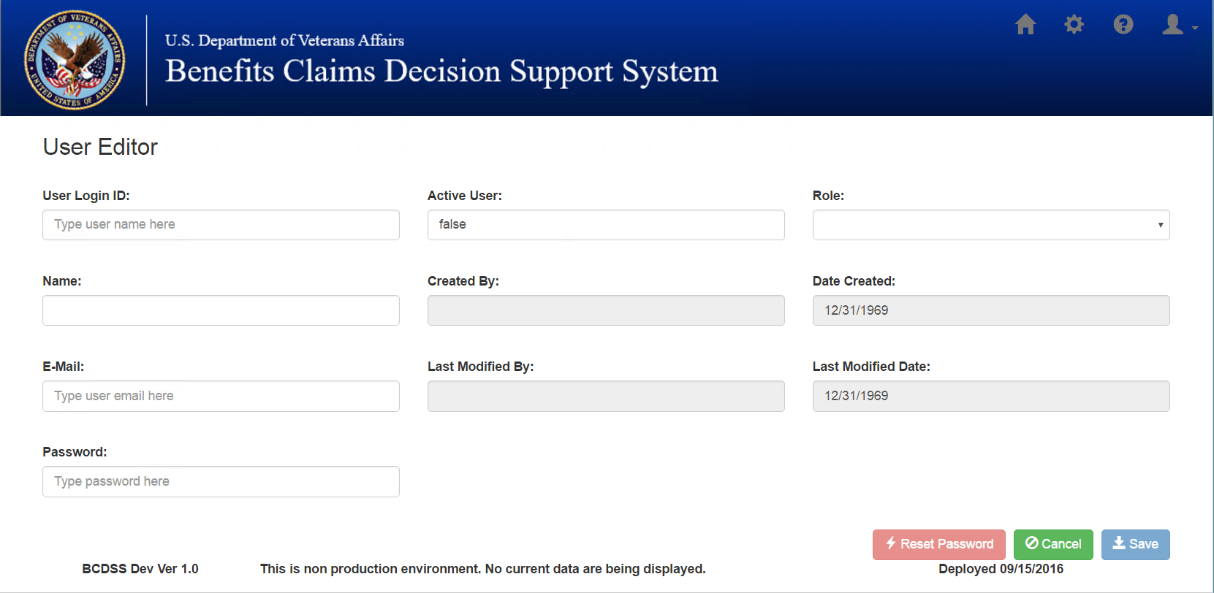

Figure : Add New User

## Administrator – Edit User

1. From the **Home** screen, select the user to edit by clicking **Edit** on the right side of the displayed user.
2. The **User Editor** screen is displayed with the current details.
3. Update the details and click **Save** to update the user’s profile.

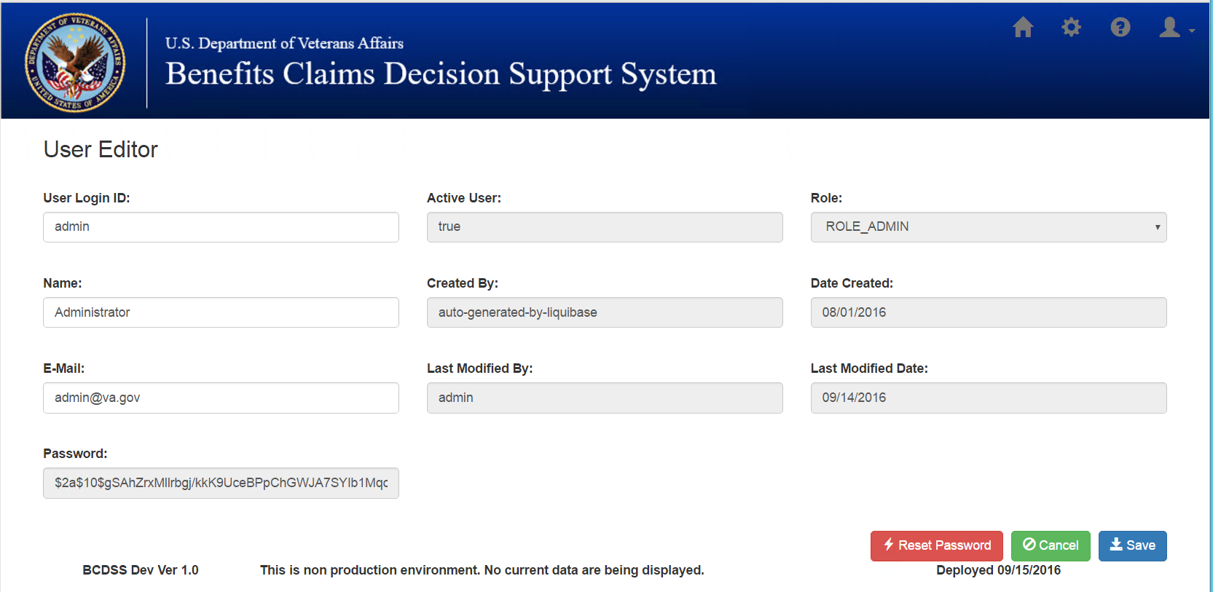

Figure : Edit User

## Administrator – Reset Password

1. Click **Reset Password** from the **User Editor** page to reset the selected user’s password.

# Reports

This section outlines the report fields.

Table : Rater Report Fields

|  |  |
| --- | --- |
| **Field** | **Description** |
| User ID* |  |
| Session Date | The date the user applied the model to generate the specific result |
| Model Result ID | Unique identifier for the result generated by the model |
| Veteran ID | Unique Identifier for each Veteran/Customer |
| Claim ID | Unique Identifier for each claim filed by the Veteran/Customer |
| Date of Claim | The Date used to calculate when the Veteran filed the claim for benefit |
| Model | The name and version of the model applied by the user |
| Prior Relevant Diagnostic Codes | Diagnostic codes used in prior ratings |
| Prior Rating | The prior rating (or CDD) included in the matched pattern |
| Priort Rating Age (Yr) | The elapsed period of time (in years) between the date of claim and the effective date of the prior rating |
| Modeled Target Claim Rating* |  |
| Actual Target Claim Rating* |  |
| Pattern Accuracy Rate | The number of times the matched pattern as resulted in the same rating as a fraction of the number of times it has occurred within the last 8 years |
| Pattern Rate of Use | The number of times the matched pattern has occurred within the last 8 years |

*Field description will be provided in an updated version of this document.

Table : Rater Report Displayed Fields

|  |  |
| --- | --- |
| **Field** | **Description** |
| Session Date | The date the user applied the model to generate the specific result |
| Model Used | The name and version of the model applied by the user |
| No. of Claims | The number of claims against which the model has been applied |
| Model Result ID | Unique identifier for the result generated by the model |
| Select | Check box to view the details of the selected item |

Table : Modeling Agent Report Fields

|  |  |
| --- | --- |
| **Field** | **Description** |
| No. of Sessions | The number of individual sessions in which users have applied the selected model |
| No. of Claims | The number of claims against which the model has been applied |
| Earliest Date* |  |
| Latest Date* |  |
| No. of Patterns | The number of patterns for the selected model as matched to target claims |
| Average Stated Accuracy | The average of the accuracy levels of the patterns matched to target claims |
| Actual Resulting Accuracy | The number of times the modeled rating equals actual rating as a % of the number of claims for which the model returned a result (matches) |
| % Agree | The number of times the RVSR/Rater agreed with the rating generated by the model as a % of the total number of claims for which the model returned a result (match) |
| Claims Rated | The total number of claims for which the model returned a result (Match) |
| % Throughput | The total number of claims for which the model returned a result (Match) as a % of the total number of against which the model was applied. |

*Field description will be provided in an updated version of this document.

Table : Modeling Agent Report Displayed Fields

|  |  |
| --- | --- |
| **Field** | **Description** |
| Session Date | The date the user applied the model to generate the specific result |
| User ID* |  |
| Run Type* |  |
| No. of Claims | The number of claims against which the model has been applied |
| Avg. Error Rate* |  |
| Model Result ID | Unique identifier for the result generated by the model |
| Select | Check box to view the details of the selected item |

*Field description will be provided in an updated version of this document.

# Approval Signatures

|  |  |  |
| --- | --- | --- |
| This section is used to document the approval of the User Guide Document. The review should be conducted face to face where signatures can be obtained ‘live’ during the review. If unable to conduct a face-to-face meeting, then it should be held via LiveMeeting and concurrence captured during the meeting. The Scribe should add /es/name by each position cited. Example provided below.  The Business Sponsor and Project Manager are required to sign.  ______________________________________________________________________________  Signed: Date:  < Business Sponsor >  ______________________________________________________________________________  Signed: Date:  < Project Manager > | |  |
|  |  |  |